CS342/CS343 Spring 2022   
Instructor: Professor Izidor Gertner

Azwad Shameem - 2/16/2022

Fixed Point Representation

(-1) \* (1000 0011) + (.001) = -(27) + (2 + 20 + 2-3)

= -999/8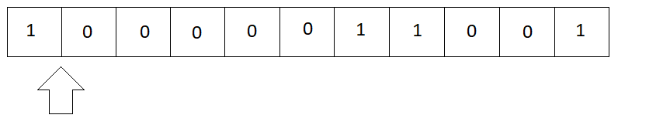

The decimal was shifted to the left seven times from the original.

Two ways to solve this problem.

-999/8 ⁒ 27 = -999/1024

OR

-1 + (2-6 + 2-7 + 2-10) = -999/1024

The decimal is shifted right two places from the original.

Two ways to solve this problem.

-999/8 \* 22 = -999/2

OR

-(29) + (23 + 22 + 2-1) = -999/2